Welcome Riverside Raptor Kindergartens!

Join us in a virtual nursery rhyme week!
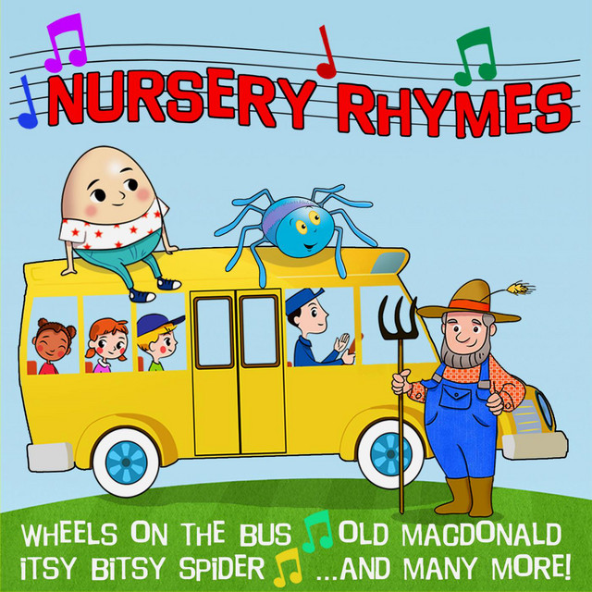

We would love nothing more than to be able to conduct this program in our classrooms but since we cannot, we will share our favorite nursery rhymes and activities with you.
Again, it is not mandatory that you take part in this program, but if you wish to do so, we would love to hear/see from you! We will send you 1 nursery rhyme per day along with some activities!

Happy Nursery Rhyme Week!
From Your Favorite Kindergarten Teachers Who Miss You Very Much!

DAY 1-The Itsy Bitsy Spider

Options to read the nursery rhyme:
- You may have a copy of the rhyme in your home library
- Click this link for an online copy
https://www.youtube.com/watch?v=w_lCi8U49mY
- You can recite the nursery rhyme from memory
** Remember to add any actions to your nursery rhymes

The itsy bitsy spider crawled up the water spout (crawl your fingers up your arm)
Down came the rain, and washed the spider out (slide your hand down your arm)
Out came the sun, and dried up all the rain, (two arms over your head)
and the itsy bitsy spider went up the spout again (crawl your fingers up your arm)

Activities:

- Ask your child which words rhyme (spout, out, and rain, again). Notice that the endings are the same.
- Create your own spider! This can be a drawing, or you can make a spider using recycled materials like an egg carton! https://www.dltk-kids.com/crafts/insects/mspidercarton.htm
Be creative, if you do not have googly eyes, you can draw your eyes on. If you do not have pipe cleaners for legs, make some legs out of paper. Find materials that you have in your house, do not go shopping:)
- Using a construction toy in your home ( ie, legos, connects) build the spiders spout. You can even use your homemade spider to crawl up the spout while you say the nursery rhyme.
- If you have access to a printer, or even if you don’t you may be able to recreate some of these printable activities on your own paper. https://www.dltk-kids.com/crafts/insects/mspidercarton.htm

