DAY 2 -Humpty Dumpty
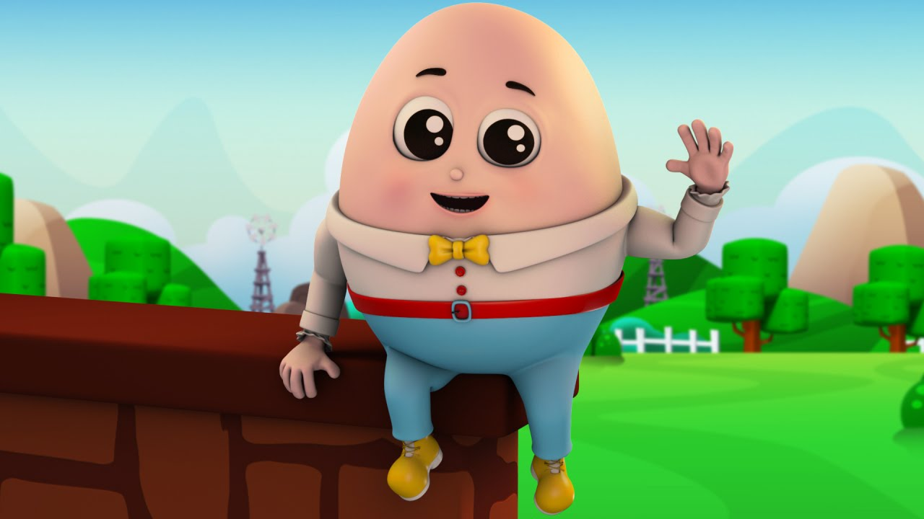

Options to read the nursery rhyme:
- You may have a copy of the rhyme in your home library
- Click this link for an online copy
https://www.youtube.com/watch?v=nrv495corBc
- You can recite the nursery rhyme from memory
** Remember to add any actions to your nursery rhymes

Humpty Dumpty sat on a wall,
Humpty Dumpty had a great fall
All the king's horses and all the king's men
Couldn't put Humpty together again.

Activities:

- Gravity Predictions! Poor Humpty couldn’t defy gravity on that wall. Your child could collect some items they would like to test heavy and light concepts with. Drop two objects from a distance, see which one hits the ground first. The one that hits first is the heaviest! This would be a great outdoor activity:)
- Using a construction toy in your house (legos, connects) create a wall that humpty dumpty has to be able to sit on without falling. If you’re feeling wild, boil an egg to test your wall!
- Humpty Dumpty Craft (some options):
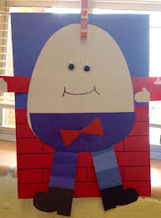 Can use construction paper or regular paper and color appropriately.
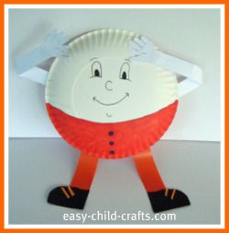 Can use a paper plate.
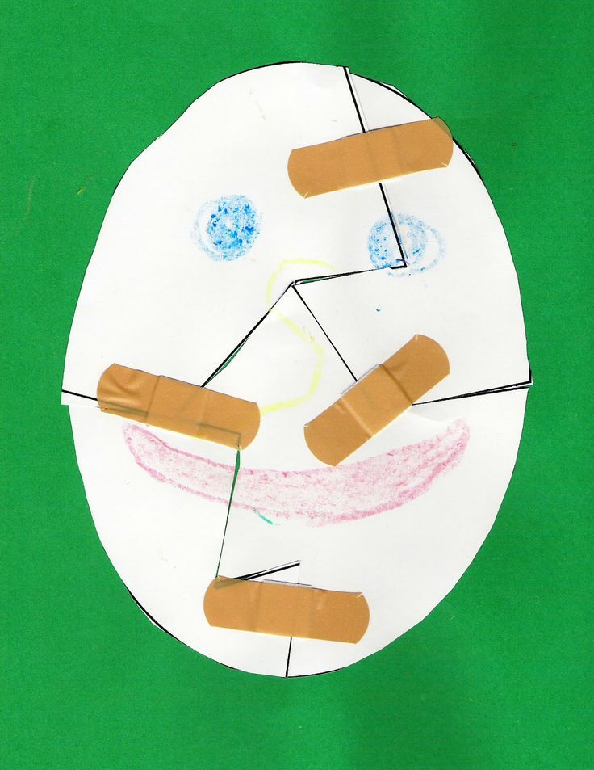Bandaids are a creative way to build humpty as well!

