DAY 3 - Twinkle Twinkle Little Star
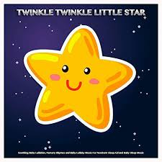

Options to read the nursery rhyme:
- You may have a copy of the rhyme in your home library
- Click this link for an online copy
https://www.youtube.com/watch?v=yCjJyiqpAuU
- You can recite the nursery rhyme from memory
** Remember to add any actions to your nursery rhymes

Twinkle, twinkle, little star, (pretend your fingers are stars and wiggle them)
How I wonder what you are! (Pointer finger to your chin like you are wondering)
Up above the world so high, Like a diamond in the sky. (hands overhead, and then make a diamond with your two pointer fingers and your two thumbs by putting them together)
Twinkle, twinkle, little star, How I wonder what you are! (pretend your fingers are stars, and wiggle them)

Centers:

- Craft: make a twinkle star - Cut a star shape from recycled cardboard and cover it in aluminum foil. If you can hang them around your house:)
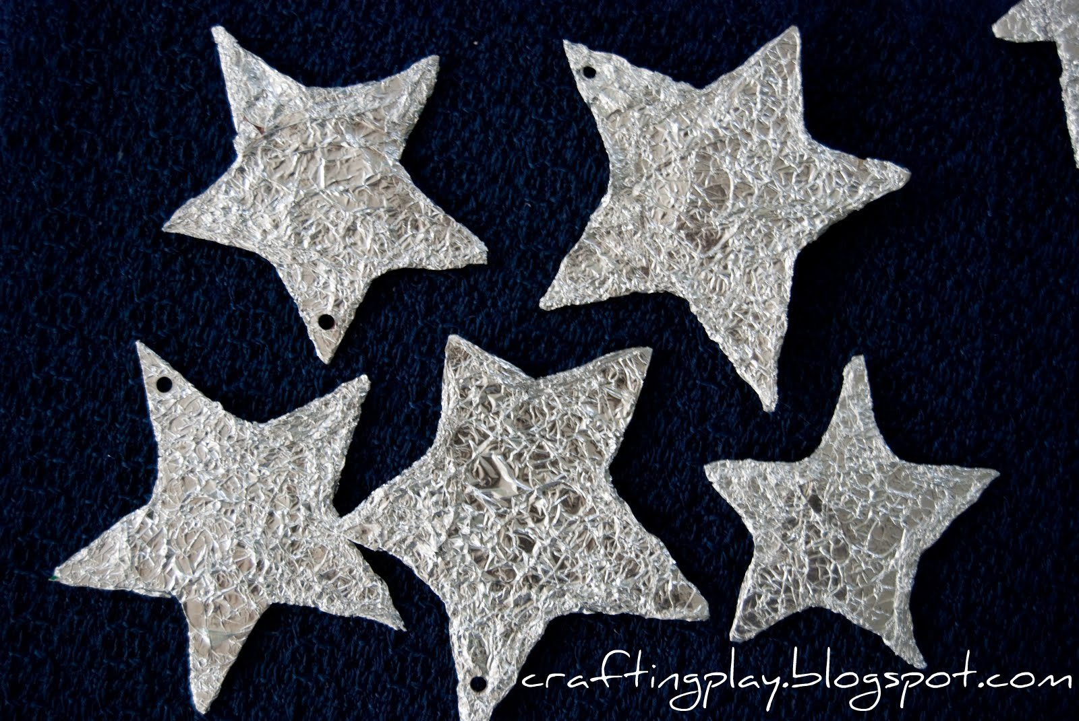
- If you have access to a printer: https://www.dltk-teach.com/rhymes/twinkle/index.htm
- 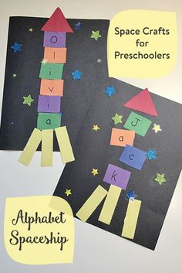 Create a spaceship with your childs name to visit the stars:)

- Set up a fort with blankets and chairs or maybe you have another creative way. Create some stars with paper and put them up in your fort. Use the fort as a reading area:) You can even use your flashlight!

