DAY 4 - London Bridge is Falling Down

Options to read the nursery rhyme:
- You may have a copy of the rhyme in your home library
- Click this link for an online copy
https://www.youtube.com/watch?v=JUke3Hnv8o4
- You can recite the nursery rhyme from memory
** Remember to add any actions to your nursery rhymes

London Bridge is falling down,
Falling down, falling down.
London Bridge is falling down.
My fair lady.

Activities:

- Gather your family (if possible) and create a bridge. Look at the following video for directions: https://www.youtube.com/watch?v=4NGwVpt3MGc
- Construction: Use materials found in your home (paper, popsicle sticks, straws, legos, etc.) and build a sturdy bridge. You can test the bridge using your toys!
- Craft: 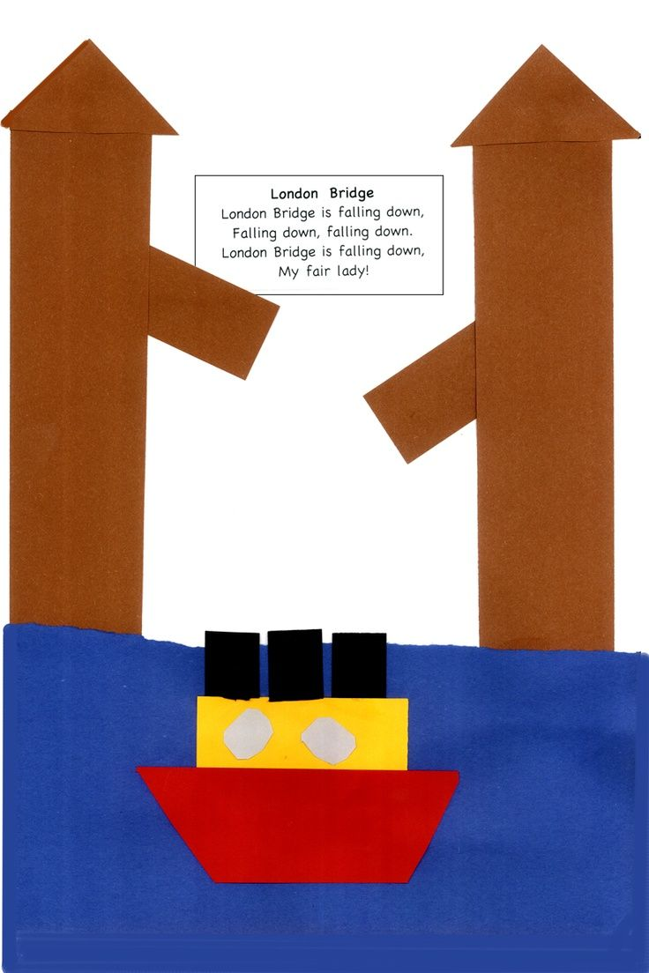 Draw a bridge and boat.

